Auto Hub Week 12 – “Human Resources 101 in 2020” June 29th, 2020

Ric Gregson-Moderator https://www.linkedin.com/in/ric-gregson-37011723/
gregsonric@yahoo.com
Ian Nethercott-Moderator https://www.linkedin.com/in/iannethercott/
ian@nabthat.com
Tiago Nunes-Notes https://www.linkedin.com/in/tiagonunessilva/
tnunes@wagonmaster.net

This Weeks Topic “Human Resources 101 in 2020”

Jesse Kessel – Director of Operations at Auto Careers Group
LinkedIn: https://www.linkedin.com/in/jessikesselautomotiverecruitmentjobshiring/
https://autocareersgroup.com/

Sandy Zannino – Found and CEO Innovative Auto
LinkedIn: https://www.linkedin.com/in/sandy-zannino-sphr-shrm-scp-92a0ab5/
http://www.innovativeautohr.com/

Call count 10 plus

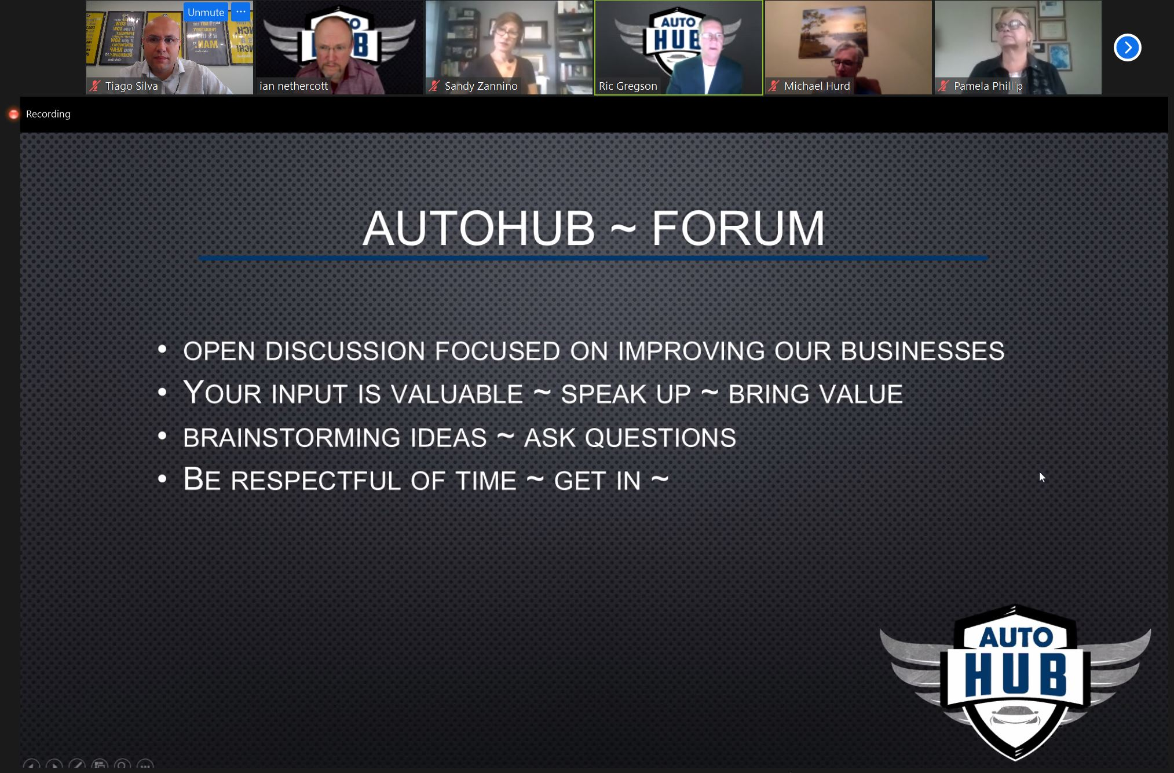

Ric: How do we screen and evaluate candidates? How to On-Board New Hires?

Ric: 1989 I have learned great techniques that I still use to date. It is a great update with our experts here today.

Jessi: I have joined 8-9 months ago my current role.

Jessi: My percetion of Recruting was to post a role, wait for qualified applicacants and interview.

Jessi: The other portion of hiring is called hunting. We are supposed to get our phones and cold call.

Jessi: We really need to get an overview of our process doing both hunting and postings.

Ian: In regards to technicians what would be the approach?

Jessi: Right now we have a more evaluation and assesment recruting solution. We go trough 5 steps. We are pre qualifing people over the phone before even get to the interview. A pre qualification call takes from anywhere from 15-20 minutes.

Ric: On the pre qualification call. There is a lot of things that we can do. What do I ask and say during those calls?

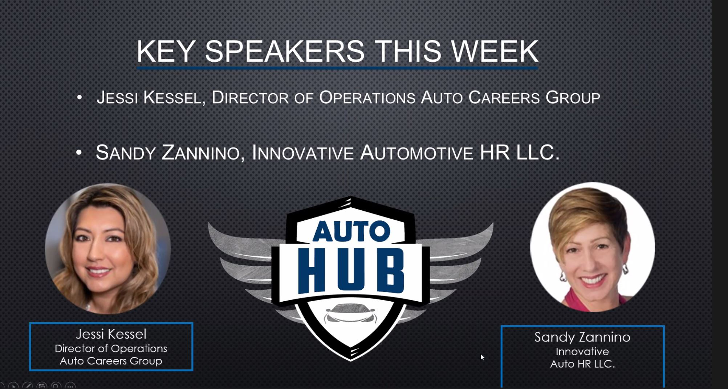
Jessi: Slow the process down a little bit so it is possible to re ask questions. Not everyone is straight forward with there answers.

Jessi: Understanding if someome got a package to leave vs laid off is important.
Ian: Dealerships could improve in which ways?

Jessi: In death digging will pour more qualified candidates in front of the decision maker. Examples of tools are profile tests and skill testing.

Jessi: Lets say someone score low on cold calling. It does not mean they wont be able to perform. The decision maker might ask questions to better understand if that person requires more input with training to further develop.

Jessi: Reference checking is important as well. Usually we look for someone of management level.

Ian: Do you feel that Dealers mainly use your services in managerial level?

Jessi: Mainly right now is for management level. Turn over in sales roles is around 80% if you are more specific to women it is 99%. The turnover with our 6 months guarantee goes as low as 6%.

Jessi: Turn over in dealership in genral is 40%.

Ian: Why the turn over is so high for women in your perspective?

Jessi: It starts with day 1 onboarding process. We have room for improvent and the numbers don`t lie.

Ric: There is tremendous systemic problem in our industry. Thank you.

Ric: Let me ask Sandy, what are some of the things that we are simply not doing it right?

Sandy: Our issue is turnover is right on as Jessi said. There is not a magic bullet that will fix all the problems.

Sandy: We should be asking: Why are you interested in working in this dealership?

Sandy: Onboarding is really critical. People are left behind with close to almost none feedback in their first days of work.

Sandy: Imagine if we have someone to welcome people, bring them to a room with coffee and a nice video and introduction process?

Sandy: Dealers should be looking at their employees as customers. Treat everyone with high level of ethics and professionalism.

Sandy: The begguining of engaging with our people is critical. Employees are making decision to stay or not.

Sandy: Delivering a cheerleader enviroment.

Ric: Employee are an asset to our organization. It is very imporant to create the culture of the employee being a customer. Jessi what would be your view on that stand point?

Jessi: We have to start to qualify our customers, I mean dealerships we work with. To be able to develop a quality retention program I absolutely agree with the statement our employees are our customers.

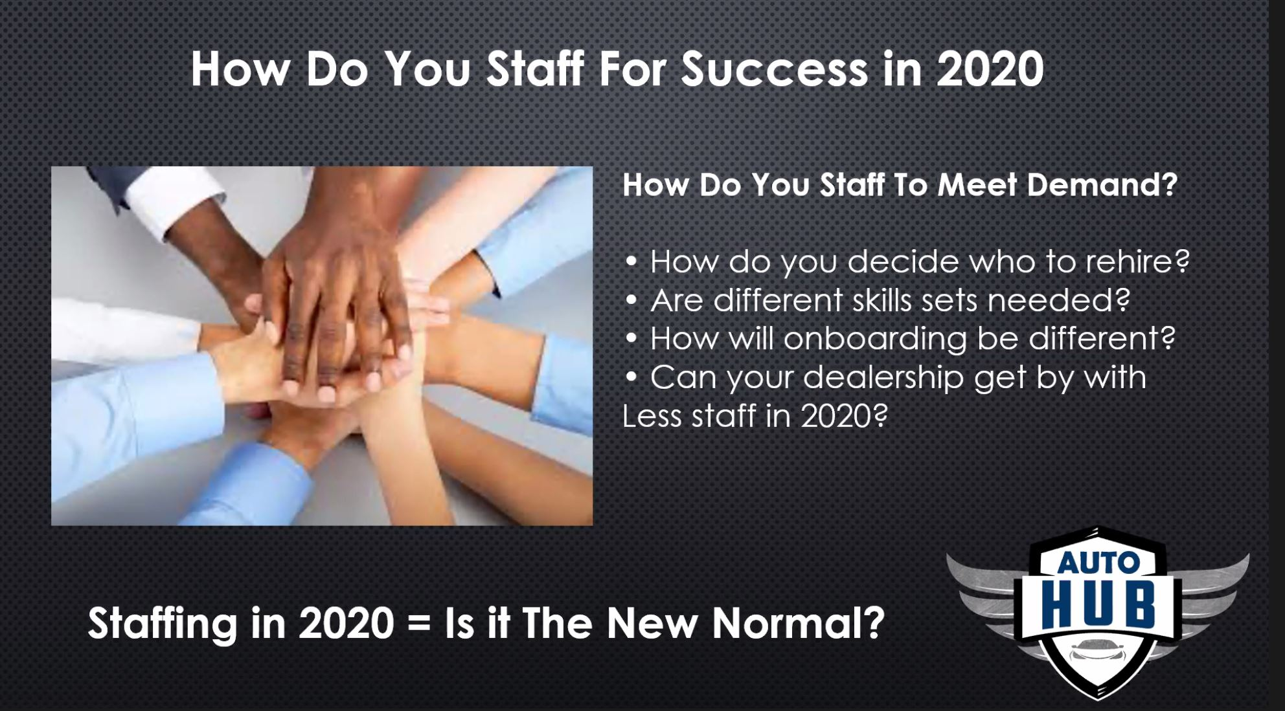

Sandy: It comes down to trust. The turnover of a high trust enviroment is around 32%.

Sandy: Make a list of all the activicies that each employee needs to acomplish.

Sandy: Every dealer is unique. Proper trainning is avoided completely. We all had to become agile due to COVID-19.

Sandy: Example new safety protocols due to COVID-19. We need communicate our message in different ways in order to meet complience of the new safety protocols.

Sandy: There are so many different process now with technology.

Ric: How do we begin with a employee peformance evaluation? How do we handle employee coaching?

Pamela: I actually ask an employee what are their imput to the process and if they are happy with the enviroment that they are in.

Pamela: Usuaully they will open up to share their findings. Some times they would like to move from role A to role B in a different place of the same company.

Barry: Listen to the people that are leaving. This is a great way to fix the onboarding procedure. Don`t lie to yourself and be transparent with the pain to fix. I recommend having a 30 60 90 days meetings with all employees.

Barry: Acutally 90 days should be revised to 80 days before we make a decision to continue with an employee.

Ric: Having a checklist specially in the 1st 3rd and 7th day of evey employee.

Barry: We all have luncheons on Mondays. We clear old employees business cards.

Tiago: Job desciption vs contract of expectations are a worthy tool to drill down. In order to drive transparency and really engage employees showing them the benift for working at our facilities that often go by unnoticed. A lot of buildings have awsome coffee, brilliant busisines cards, area to play and relax.

Tiago: Management expectations with employee metrics agreement. Aligned with what type of enviroment each employee is placed creates a way to drive forward our results.

Ric: Should we have job descriptions to all of our employees?

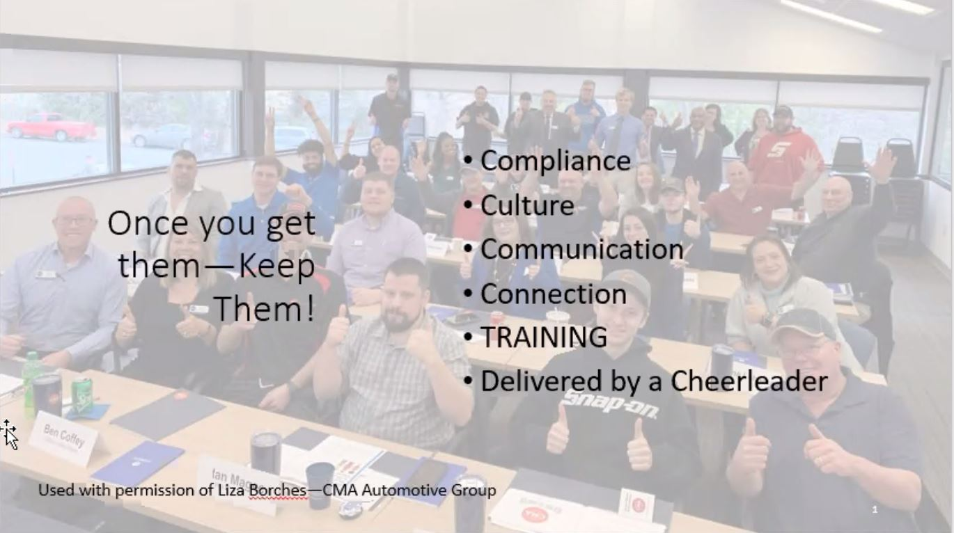

Sandy: Peformance agreement is really important to get action in place. Job descriptions brings clarity to our roles. Having both of those elements will prevent many legal disputes.

Ian: A closing note is that Job description will get us better today than yesterday.

Ric: At CDK I have one and it is awsome to be able to measure myself againts expectations and move forward.

Ric: Thanks everone for your presence!

Ian: Great meeting!

All: Multiple people agree

