Auto Hub Week 15 – “Marketing in Automotive” July 20th, 2020

Jeff Polo -Moderator https://www.linkedin.com/in/jeff-polo-b2602216/
jeffpolojdp@gmail.com
Ian Nethercott-Moderator https://www.linkedin.com/in/iannethercott/
ian@nabthat.com
Tiago Nunes-Notes https://www.linkedin.com/in/tiagonunessilva/
tnunes@wagonmaster.net

This Weeks Topic Marketing in Automotive

Barry D. Jordan – White Glove Group

LinkedIn: https://www.linkedin.com/in/barry-d-jordan/

Robert Karbaum – Head of Business Development, Kijiji Autos (An Ebay Company)
LinkedIn: https://www.linkedin.com/in/robertkarbaum/

Call count 20+

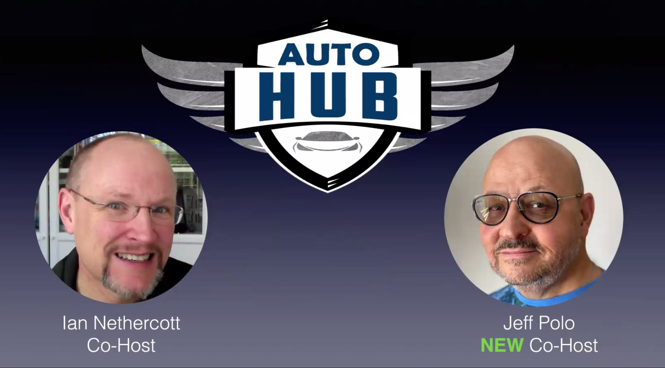

Ian: This week we are talking about sales and marketing. Welcome, everyone!

Ian: Goes over housekeeping items.

Jeff: Welcome everyone. Glad you all join us today.

Jeff: Barry has a very very deep knowledge of the automotive segment.

Jeff: Created a solution and he is going to be kind to share with us all.

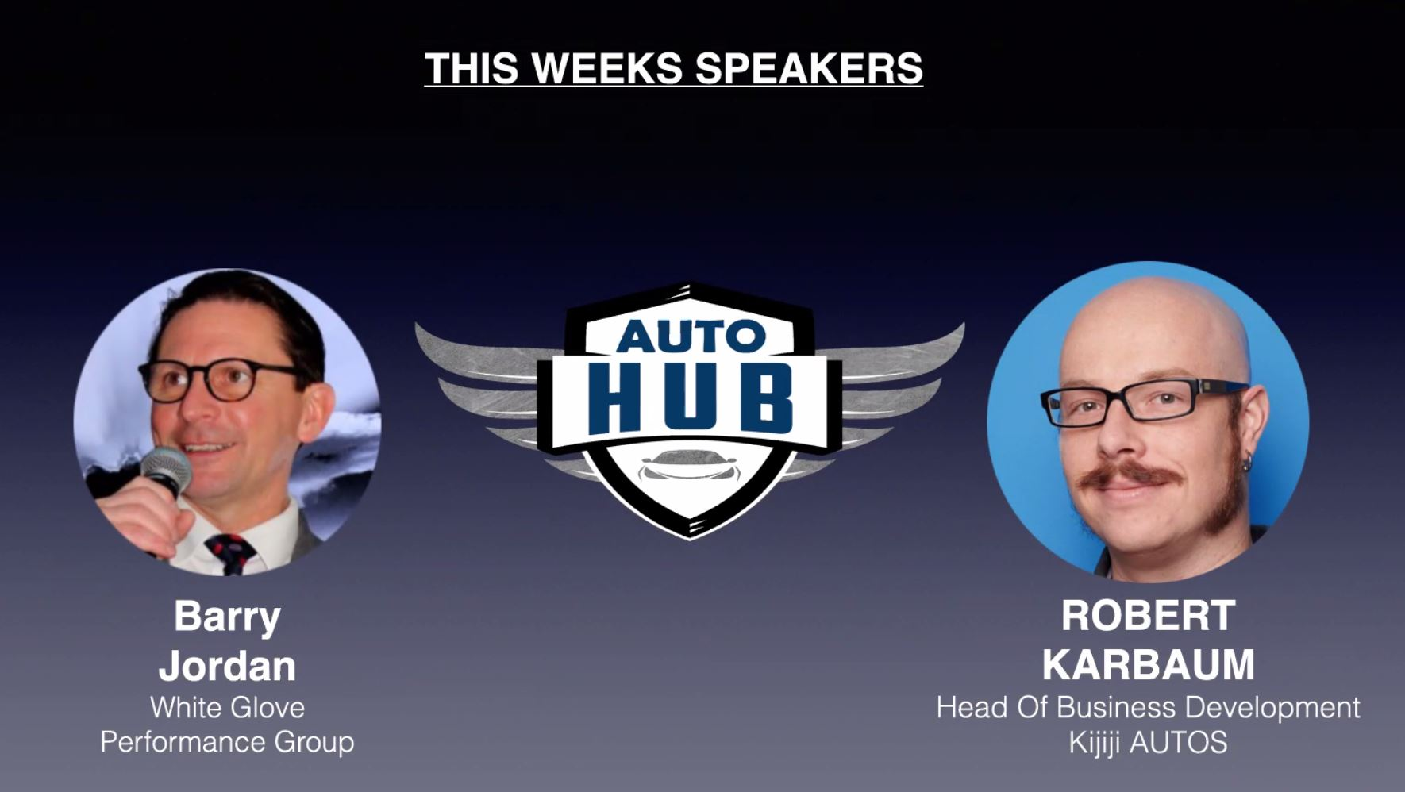

Barry: How clean is your database? Does your e-mail get ignored?

Barry: 500 – 800 dollars to acquire a brand new customer.

Barry: 30 – 40 dollars in the current database to convert sales leads.

Barry: Every contact should not be a sales contact. Typically we start with a newsletter.

Barry: 1-page newsletter a month. When you are reaching out with relevant information your attention will raise organically.

Barry: You should be calling everyone that did not buy a car yesterday to gather feedback.

Barry: Every time that the OEM changes something. It is important to call all your customer base.

Barry: When a salesman leaves the company the next person should call all the database.

Barry: The key here is the cadence of relevant connections.

Jeff: Why would a dealership do not perform those tasks?

Barry: Mainly because the database is not clean enough to be filtered and targeted.

Barry: They go to the traditional way marketing with the radio guy.

Jeff: How important is the cadence of the message?

Barry: If you haven't formed a meaningful relationship in a normal way, COVID-19 was a great opportunity to generate bonding & rapport with our customers.

Barry: The key here is not only focused on sales, sales, and sales. First, you need the decide on the Journey you will take the customers, and cadence would be 2nd priority.

Jeff: Digital marketing is mainly free. What are the best practices?

Barry: There is a whole building up connecting the dots in the dealership. Sales should know what the service is doing.

Tiago: How important is to present the dealership fixed operations side of the business while the customer buying a new car? Any ideas on how to tie that to the Journey of the customer?

Barry: It is crucial. Here are some of the best practices I have seen: Service side calls the customer after one day of experience to make sure everything went well driving home.

Barry: The service manager will confirm all the database information. Making sure it is ok to follow up with the customer in the future.

Barry: Another great way is to mention that next week we have a new owner's clinic and we would like to invite you.
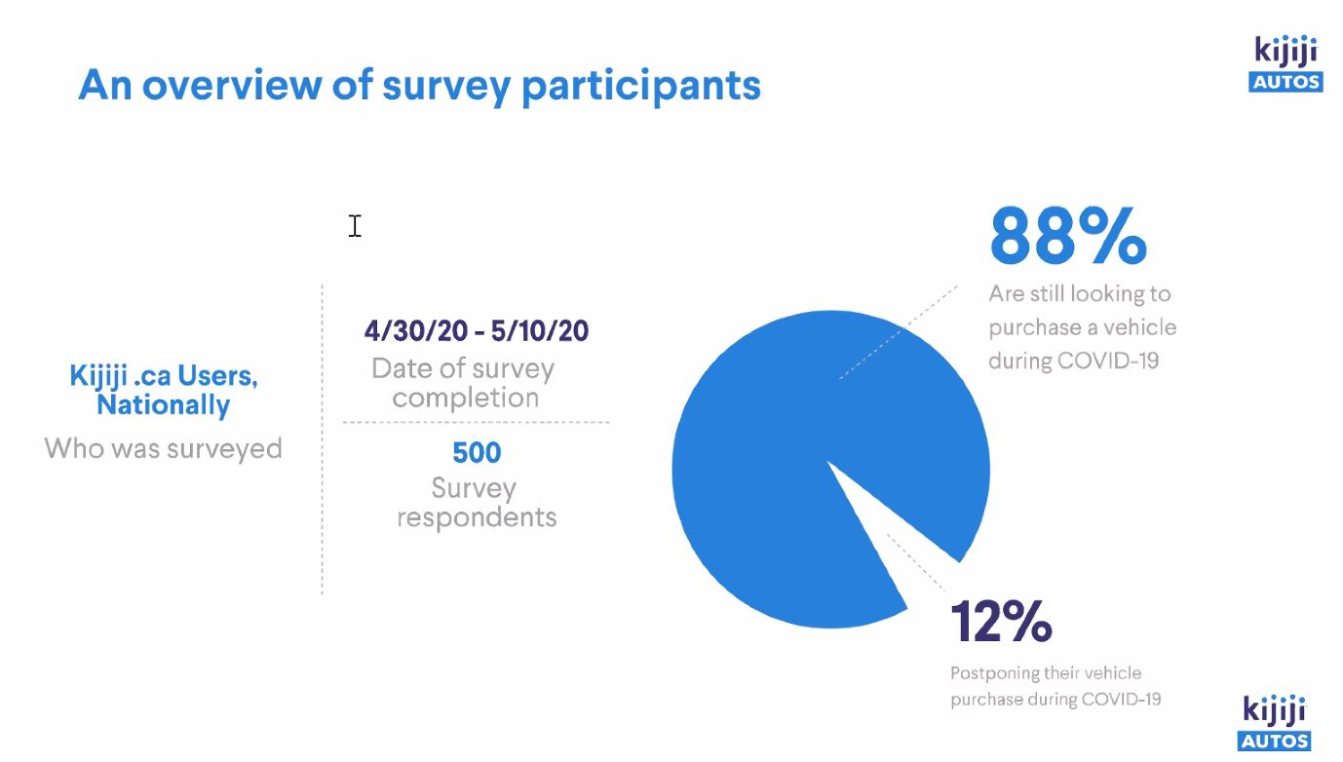

Robert: I worked with marketing, CRM, sales of services and currently I am the Head of Business Development of Kijiji.

Robert: We study photos, descriptions, and consumer trends.

Ian: What are the top 3 reasons Canadians are looking for cars right now?

Robert: 77% of online car shoppers still intend to purchase their vehicles between now and 2-3 months.

Robert: 60% of those surveyed are delaying their purchase until they can safely test drive.

Robert: Currently there is a backlog. 36 out of 34 sales originated from an e-leed of a phone call.

Ian: How to keep the leads warm while the customers are not coming to the dealerships.

Robert: We need to be cognizant of what we are sending to everyone.

Robert: We need to customize our language and reduce the churn rate.

Robert: We spend time humanizing our relationships. Picking up groceries for customers is a great way to improve bonding & rapport.

Robert: Whatever you do make sure it is honest and good. Capture that in video and share it in social media.

Robert: We are still in the role to sell cars. The difference is that storytelling online is becoming huge in importance.

Ian: Even a small dealer group could be doing that. It does not take massive resources to be successful.

Robert: When you are huge it takes more time to get momentum.

Robert: Your online presence as a dealer should be as good as your physical experience.

Barry: We are being compared to all other good retailers in a different segment.

Ian: Thanks everyone for being here.

Jeff: Thank everyone for attending.

