Auto Hub Week 8 – The Retailers- “Digital Retail” June 1st, 2020

Brandon Sanchioni-Host https://www.linkedin.com/in/brandon-sanchioni-279666181/
brandon.sanchioni@hotmail.com
Ric Gregson-Moderator https://www.linkedin.com/in/ric-gregson-37011723/
gregsonric@yahoo.com
Ian Nethercott-Notes https://www.linkedin.com/in/iannethercott/
ian@nabthat.com

This Weeks Topic “The Retailers – Digital Retail”

Jason Silberberg – CEO Nabthat Jason@nabthat.com
http://www.nabthat.com
Linkedin: https://www.linkedin.com/in/jasonsilberberg/

Michael Sanders – CEO Dealer Vision
https://dealervision.com/
Linkedin: https://www.linkedin.com/in/michael-sanders-6712827/

Call count 50 plus

Ric: A quick Thankyou to Brandon for starting “Autohub” he will no longer be a host due to the time he needs for his new store. We wish him all the best in his new venture.

Ric: Be ok with other people using ideas on this call

Vendor’s speak Friday sessions “More Details Soon”
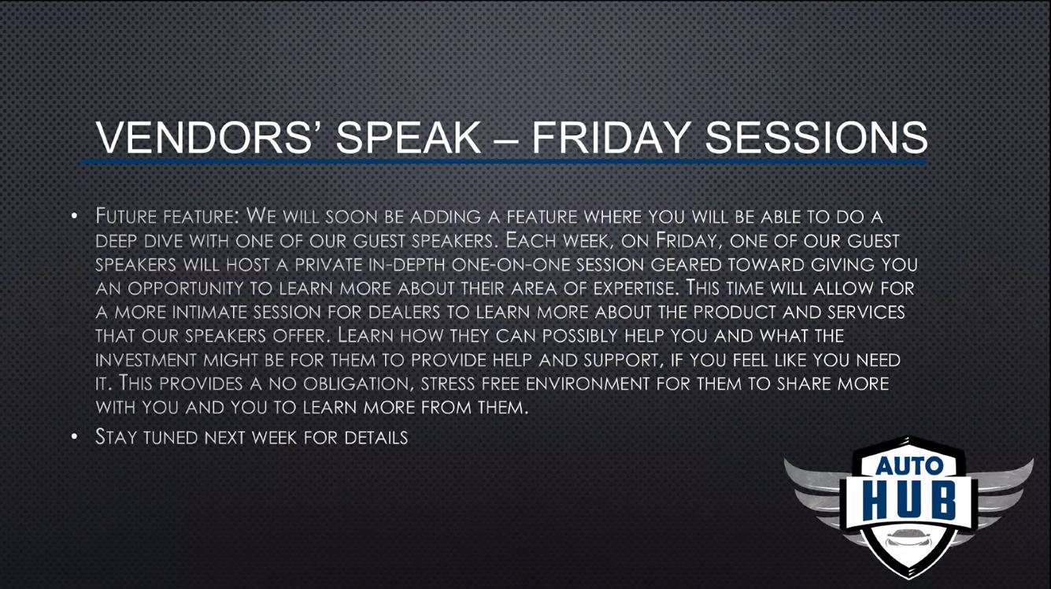

Ric: Be respectful of everyone’s time on the call and ask questions.
Don’t be afraid to push the speakers.

Ric: First of all, I would like to discuss “Mobile” and how important this is today

Jason: What we are noticing is that 65% of the traffic is coming in through a mobile device. It is very important that you are looking at your website as the first place of interaction with a consumer today.

Jason: You really need to look at your digital real estate and how you are using it. Are the third-party companies on your website fighting for digital real estate on mobile devices and not in a good way? Are these products inhabiting the calls to action? Chat bots, etc.

Ric: How do we stay engaged with our customers to make sure this does not happen.

Jason: you need to work with your website provider to make sure the integration works seamlessly, and the customer experience makes sense for the customer on your website. 70% of the time a consumer is submitting a lead the first time on the site.

Jason: Customers will leave your site quickly if they don’t like the experience.
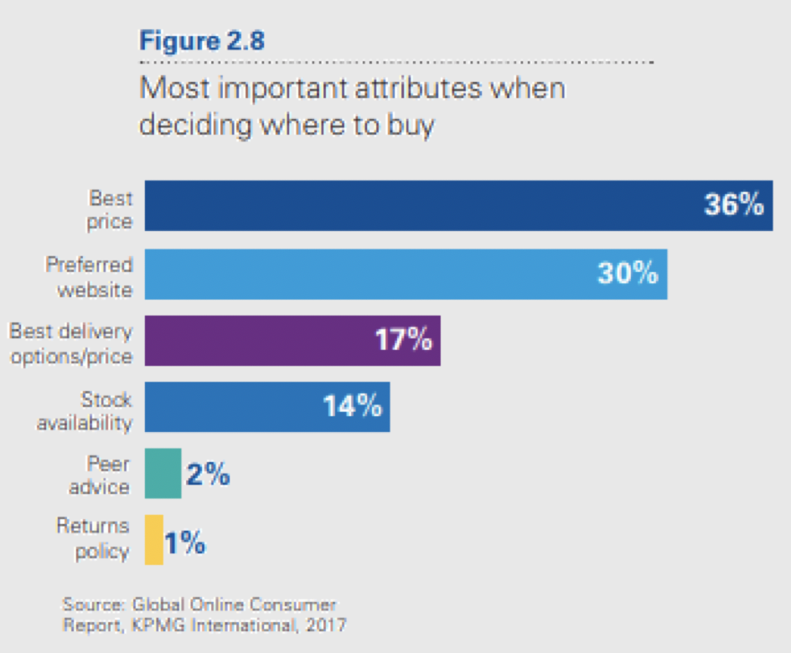

Jason: The Number one attribute is price, but a close second is experience. It is really important that the mobile experience is the best it can be. (KPMG details above)

Ric: Do you need widgets?

Jason: Some websites just don’t provide the experience and conversion you need at your dealership. We see ½ % to 1%. Conversion rate at most dealership websites today. Your team needs to look at why these numbers are so low and use all the data (KPI’s) available to make better decisions and increase conversion and sales for your dealership. Our websites integrate seamlessly with all 3rd part providers and we can increase your conversion rate from (05%-1%) to 3% to 5%.

Jason: Is your service coupon and experience mobile friendly? Nabthat websites have a mobile friendly Service and parts coupon process that converts.

Jason: Data and user experience are key components to higher levels of conversion and lower bounce rates for your dealer websites. Is your current website providing an experience that is on par with the experience your customer is familiar with elsewhere? (Amazon, Netflix, Zappo’s etc.)

Ric: What is the right combination of Video and why is it important?

Michael: Video is about educating people, informing people. Basically, helping people trust us and like us. Video is a unique position to get this done. This is supple of course, but it is powerful if done right. What am I going to run into when I visit your dealership?

Ric: What do you say to the dealer who says I’m not going on camera.

Michael: Video’s is going to show emotions, you may need a spokesperson vs the dealer principle. Covid 19 has been a tragedy, but it has also been an opportunity.

Here are a few examples:
http://www.futureford.com
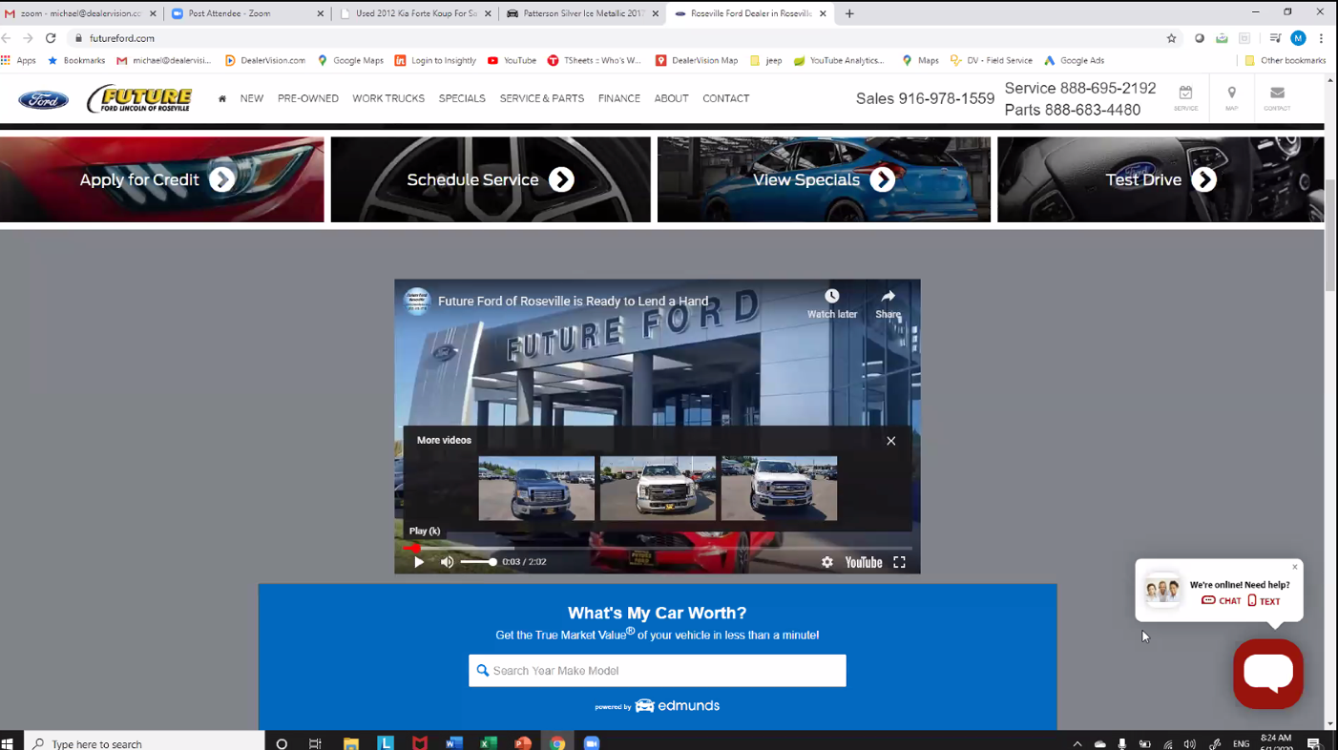

Thompson Pontiac GMC http://www.thompsonchevrolet.com

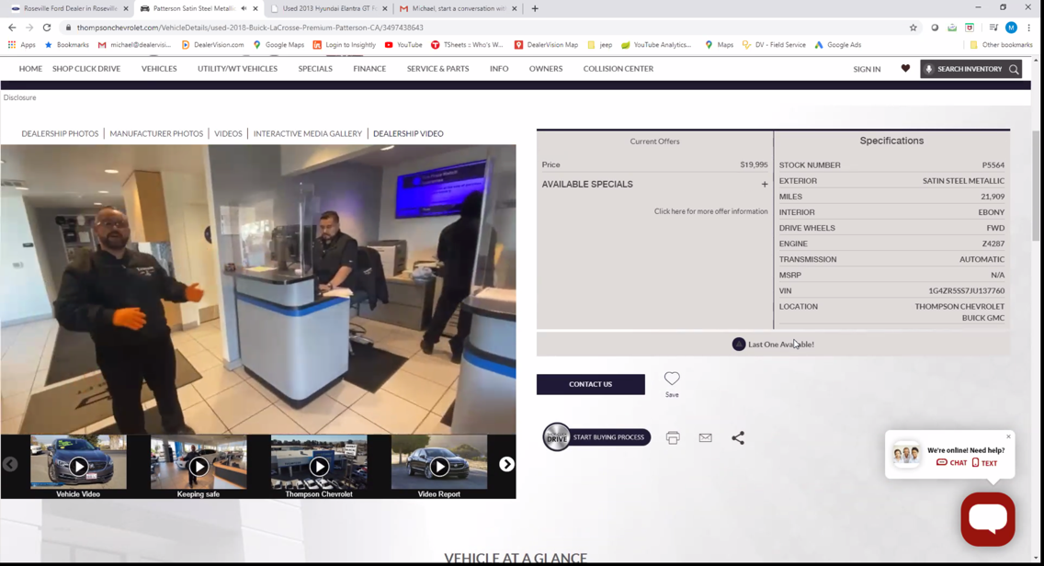

Michael: One more example Bokan Ford : http://www.bokanford.com
Using Video on the VDP page may help with conversion
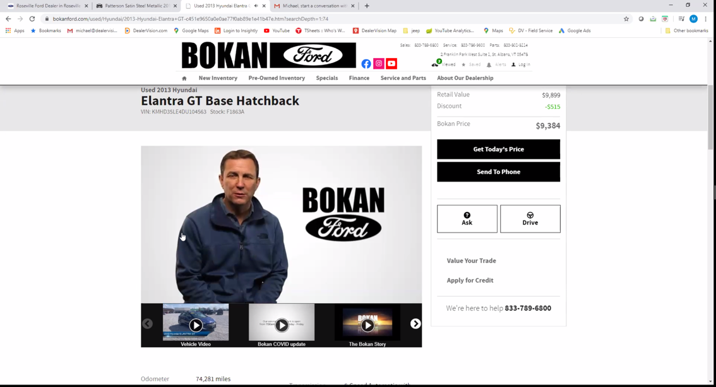

Ric: Can I expect that my website can handle this type of video.

Jason: Yes, video can be handled by most websites today. You can use video sharing sites to host the video and putting video on your website should take no longer that 10 minutes. Check with your web provider on this, we have heard from a number of automotive clients that this takes days or week in some cases.

Barry: We all know how to do this and shoot a video today.

Michael: The cell phone technology is here today. The video needs to be authentic and match your reality in store. I have a client of 20 years who is a used car manager. It’s about sharing the knowledge and the differences with customers. Showing them why they should buy a used car from your dealerships.

Jason: You tube is the #2 search platform in the world. Video can be used in multiple areas to help your business. It can be used on websites, in marketing materials and as part of marketing campaigns.

Joe Ingram: The biggest factor is a trust thing. Don’t make it perfect make it real. It will help in service, sales and trust.

Michael: it’s the beauty of video. As we know there are movies that are great and there are movies that are not worth the time. There is a right way and a wrong way to do it. We need to give them a reason to stop to increase conversion.

Ric: I had the same experience with one of my client’s web providers. Can they get it done?

Michael: Make sure the video can be seen on the right spot on your site for example. Video needs to be in the right place on your site to help with conversion.

Barry: You need to watch it and make sure you understand what the next video would be.

Michael: At least it is staying on their channel, go to your competitors for example.

Ric: Digital retail and trade in values? Our old school self is always thinking bring the vehicle in.

Christian: Not using video but asking customers to give us details on their car. We are letting them know that we are serious about buying their car either way.

Ric: Do you thinks it’s obtrusive to ask for a video.

Christian: Try to make it as simple as possible or they won’t do it.

Kim: Logan got me hooked up on Accutrade this month.

Scott: If you can get them to invest 15 minutes on facetime it will help build trust with the customer. Dealers don’t seem to be all that interested.

Kim: If they are game for it, it will work. If they are not it won’t work.

Joe: A lot of the CRMs are not allowing this video to happen. You need to have it all in the CRM. Dealers are resistant due to the lack of details in the CRM.

Barry: You need to have a process to make it work. Lonny or Penny in the tread for example.

Joe: If you give them what they need it is not a problem for the client for example.

Ric: I am a dummy; I don’t know anything about marketing. You say Conversion, KPI and VDP what are you talking about. I can sell a car, but I know nothing about marketing. What should I be focussed on my website? Can we expect the consumer to print a coupon in service?

Michael: If you have consumer looking for brake service and they go to google and look up break service on google for example. If they can’t find it create it for example. Do you have service specials on your website? What are the call to actions on your service specials? Are you going to email a friend about service for example? Mobile wallet feature vs printed. Like the airlines for example. Do you have content on your website about this on your website to back this up?

Jason: What is the experience that we are providing to the customer online? What am I providing to the customer, here is an example? We don’t want a customer to print out anything in 2020. Fixed ops up by 30% if it is done correctly online on our platform. What happens when they hit that page for example? (Example below)

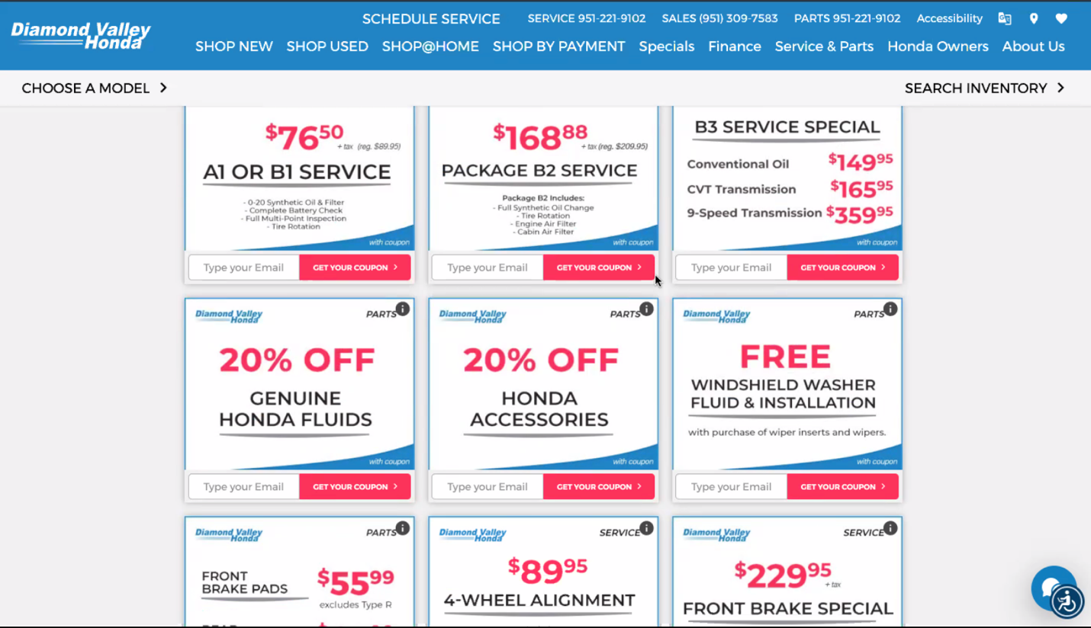

Jason: The 27-year-old taking over the family store. The amount of traffic you are getting and the conversion rate. Visits to the website and leads. If you are able to look at phone calls, chat for example. You can also look at what are you paying per click. Look at everything from an ROI standpoint. Are you paying $47 dollars per lead are you paying $27 per lead?

Ric: Do you mean price per lead submission?

Jason: Exactly and does the data match in your CRM and what is your closing rate on these leads. The data must be consistent in your CRM.

Ric: What should I be paying for a lead in Vancouver?

Jason: You must have your offence and your defence. Cover your own market first then conquest to drive growth. Make sure you back yard is protected first. Two different audiences to go after. Google drives active customers so going after active customers makes sense as a first step. Facebook is passive so you need to take that into account and consider how these customers are different and ramp up information and excitement to get more leads.

Ric: One more question, what is the recipe I should consider for my dealers. What percentage should be in what areas for example (PPC, website, Facebook, part of website).

Jason: Everything comes down to conversion. We worked with dealers in the past that did not have a Nabthat website and this did not make sense for these dealers or Nabthat. This is why we only work with our website clients in terms of digital spend. There is no one formula, every site is different as is every city and market. You need to focus on Organic traffic first. Budget 200 cars per month $30-$40 per car on digital for example. Looking at the conversion and the KPI’s

Michael: I am an old school car sales guy and video is the way to do this.

Christian: What is the cost per lead?

Jason: $30 to $40 per lead is a great starting point.

Jason: My background is in selling on mobile devices. Everything comes down to the experience on every device. We would love to show you more about Nabthat!

Ric: There was a time when digital retail did not exist. There was a time when internet experience was not important. The reality is now we need the best experience possible.

Bonus Notes from The last call:

Good is the enemy of great “We Forget That Today”.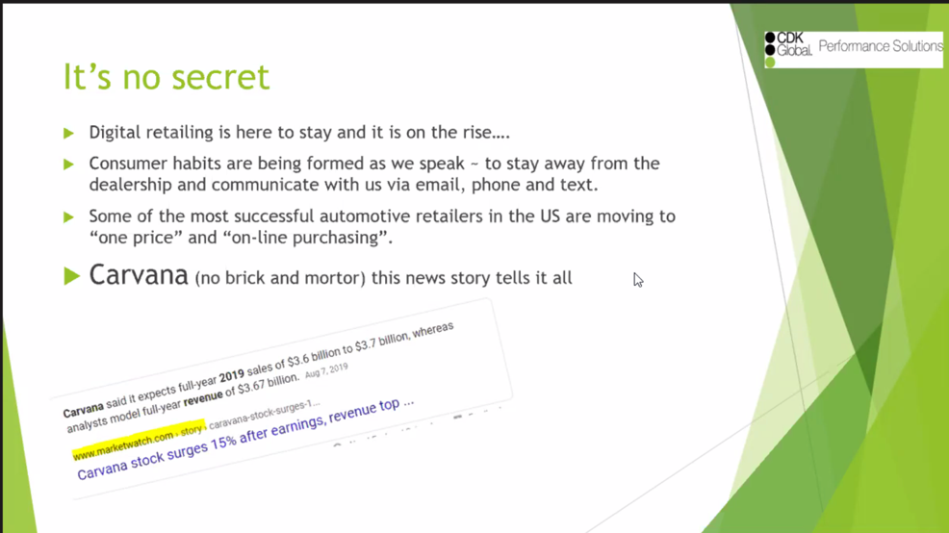

Ric: Don’t forget the “Carvana” story and the 4 billion in revenue 2019= 46,000 cars sold
Up 83% year to date
Currently 24 locations “vending machines” https://www.carvana.com/vending-machine
Ric: More and more cars are willing to purchase online in 2020, financing, F&I and more, no pressure, just information.

Ric: My son bought products in F&I without seeing an F&I person “over the phone”.

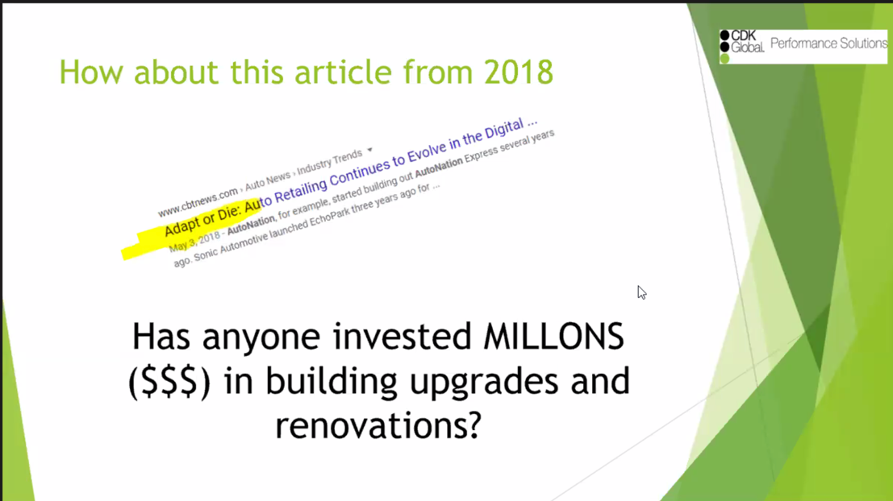

Ric: we all have two dealerships we spend million on the building, but what do we spend on the
Dealership.

Ric: what are you spending on your website?

Ric: you need to invest in the website and “Make it easy” 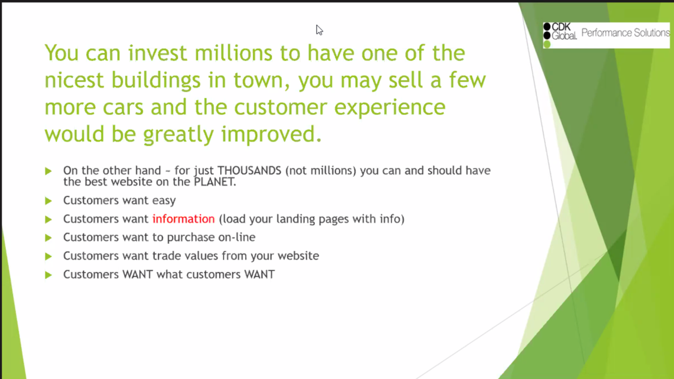

Ric: More and more customers are willing to purchase online today.
You can get a nice website for 40,000 not 4 million.

