Auto Hub Week three overview The Analyzers

used vehicle operations discussion

Starting with a quick power point for Review

Ric and Brandon Show
Notes by Ian Nethercott
ian@nabthat.com
604 240 7642

Quick video for motivation “no audio”

“I can’t wait for this year to pass; we will remember it as a time to spend with friends and family and a time to slow down and bring everyone closer”

Open discussion, brainstorm ideas and no selling

Used vehicle operations, aged inventory and pricing and strategy.

Ric: Tommy Gibbs Scott Turner, Calvin Bennett, Logan Kierstead (speaking today)

The world today is going through crisis or an opportunity depending on how you look at it. Focus on areas of opportunity. Come out as better people “better operators”. Our staff and team deserve a better opportunity. Improve ourselves and come out of this better.

No direct selling via email but stay tuned for more details below. Feel free to reach out directly to the speakers below.

Brandon: It is so important to connect with your people, even the people you have laid off. “Accountability, process and people” That is all I got.

Ric: Your inventory is aging; how do you deal with this when the auction are loaded with cars. How are you positioned in this reality to win with lower values driven by auction estimate?

Jake: focus now on reducing inventory (60 to 35 to 40). Really reduced our price point “sell it now”. Lots of internet leads, best price is important. Aggressively pricing and every deal is accepted pretty much.

Ric: What does aggressive price mean?

Jake: 80% 90% of market price. Community marketing was the way we went, but we need to be more competitive. Best price in market, pictures are very important. Pictures must be perfect.

Brandon: are dealers groups sharing inventory.

Now it’s just fair game to share stores. we used to keep the cherry cars.
Dustin: we are trying to be more selective in terms of what we are buying. We are being more selective.

Kim McPherson: Purchased them online, purchase the vehicles that are already sold. Dealers are more eager to sell right now. Even if I need to buy it retail. Leaning more on the F&I to make profit right now. The deal is structures with $2,500 on the back end anyway. Signed bill of sale first $300 to $500 on the front end. Retailing every other day, pulled marketing initiatives, all digital, now looking to scale etc. Learning every day.

Brandon: Finance call next week, great resource.

Tommy Gibbs: World renowned speaker Used Cars.
850.251.2310
tommy@tommygibbstraining.com

This is a perfect time to make changes. Is it the right time, we struggle usually? At this time there are a number of tough changes that need to be made right now.

Selling process, photo’s online, pay plans, process, pay plans etc. Make some of the changes now in terms of management, staffing etc. Factory receivables, rebates etc. Get on top of this now. Stay in contact with your current staff or former staff.

A couple of things to do right now:
One: You and your management team trade walk every day “lot walk” every-day team and management “online worst case”
Two: Adopt a car on his website for free
Three: Focus on your high dollar cars “they will be a problem” top 5 most expensive top 10 most effective “helps drive your average cost per unit down
Four: Manage your inventory but don’t buy unless you need to.
Five: Price driven, retail out of them now, cars won’t go up in value. “reprice every day”
Six: Focus on rolling 30-day count “how many cars have you sold in the last 30” Aging is a problem 60 days is now 30 days.
Seven: Invest in a photo booth, rent a space worst case. You need to have the best merchandising period. Customers are looking for amazon www. toothmanford.com in west Virginia for example.

Focus on high dollar cars, retail out of your aged inventory, you can’t wholesale out of them, keep people busy, adopt a car concept, take control of your inventory 30 day is the new 60.

Every car does not deserve the same shelf life. Some will get 30 some will get 45. Is it a bad color model etc. “decide on day one how many days the car will get”

Scott Turner CDK Global
847.252.0001
Scott.turner@cdk.com

It is great to get together with lots of dealers in this type of format.

The one thing we all know about used cars is it is like your own factory. Let’s talk about transparency and bringing the customer with you. The customer does not know what is happening on their own behalf. Why is it taking so long, customer assume to worst sometimes right!

Schedule, Record, Confirm, reception and schedule “Travers” Connect”
The new sales process in most dealerships.

The new process “the meeting invite”
Manage the customer and make it easy, best practice.

Perfect this process in terms of a meeting invite, scheduling service or sales
“make it easy” and set up an invite in their calendar and yours.

Quick example of a process

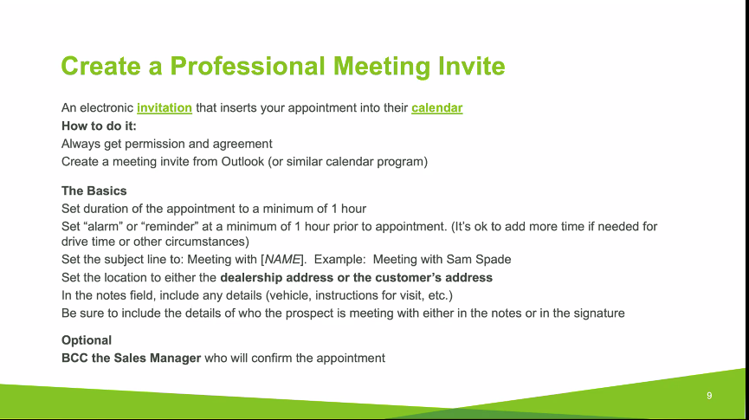

Gives people a real time update for you and your customer

There are services like Calendly that can help here as can google calendar and Gmail calendar or iCal

We need to do more than ever here in terms of “preparation” video, email etc. are more important than ever.
Using services like You Tube for example using the “unlisted” setting to leverage this powerful service.

You will need to prep the vehicle before you deliver it to their house. A quick wash video, how you will sanitize it for them. Show them what you are doing for them. Who is involved in this process for example, transparency is key. Prove what you are doing and show them for example.

Quick tour of the “store now” for example. What are you doing differently with Used vehicles for example? What makes things different at ABC motors for example.

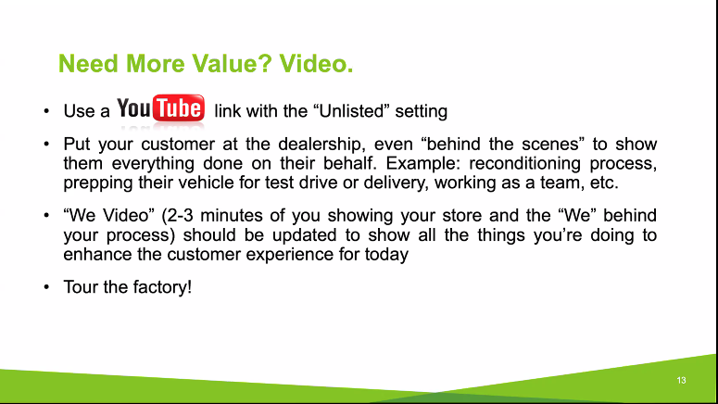

This will make your vehicle different for everyone.

Calvin Bennett
Kar Global rep for Vancouver and Vancouver Island
250.801.0396
Calvin.bennett@karglobal.com

Trends “take it very lightly” Not enough data right now “last three weeks”

Conversion: Listed vs sold “what does price mean here” higher priced units convent at lower rate right now ($3000 and over) 20% lower right now.

A little more of a delay in terms on transportation. Exporting initially died off, this is now coming back. US buyers are now buying again even with the risk. Volumes are still lower.

Appraisals: Large increase of appraisals but not a correlation to landed units. More online appraisals as expected.

Aged inventory: Not as much as you would think. Dealers are holding on to inventory right now due to challenges in the dealer’s mind in terms of replacing the inventory.

Long term projections are a 3% reduction in value.

Logan Kierstead
Accutrade “Appraisal tool” Kelly Blue book instant cash offer
506.874.7355
logan@accu.trade.ca

What we have seen is that dealers were imputing as little information as they can to get a value as quickly as possible before this Covid-19.

Dealers want value’s fast and total appraisals have gone down, but inputs are now increasing due to risk. They are now putting in more details to get a more accurate value and mitigate risk. Dealers are also reviewing information with customers.

Dealers are now deciding what to do with the car when they buy it. Certified etc. They are also taking better pictures and pushing this information to wholesale or online. Condition reports will be useful moving forward.

Logistics Tool to manage inventory in the USA.

New tool to manage inventory, drivers etc. will be live in Canada soon.
Video demo was show ask Logan for more info for Canada it is already available in the USA.

Looks like a great tool for dealers and Auction sites.

85 people on the call, next week will be a subprime week.

Higher end units are down 20%, how much is business down “trade-rev” is business down.
There is a decrease in both right now only one auction so far this month and it was online.
There will be tremendous opportunity in terms of value in the marketplace for June for example.

NabThat is presenting a demo of our Award winning products this Friday the 17th at 12:30 PST.
If you are interested in attending just email ian@nabthat.com

