Auto Hub Week 7 - Performance, Measurement, Accountability May 11th, 2020

Brandon Sanchioni-Host https://www.linkedin.com/in/brandon-sanchioni-279666181/
brandon.sanchioni@hotmail.com
Ric Gregson-Moderator https://www.linkedin.com/in/ric-gregson-37011723/
gregsonric@yahoo.com
Ian Nethercott-Notes https://www.linkedin.com/in/iannethercott/
ian@nabthat.com

This Weeks Topic “Performance, measurement and accountability”

Ken Monhollon – Next Level Automotive info@nextlevelauto.ca
Joe Ingram – BDC Genius https://www.linkedin.com/in/joeingram/
joe@ingraminteractive.com

More of a roundtable discussion this week – more ideas for everyone

Call count 84 so far……
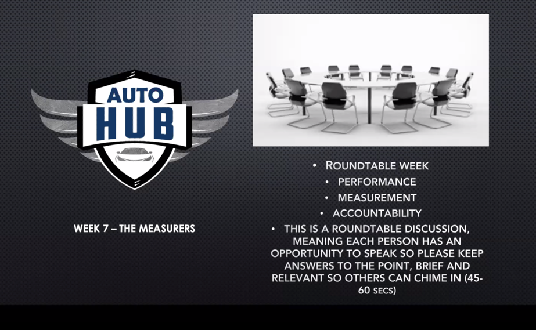

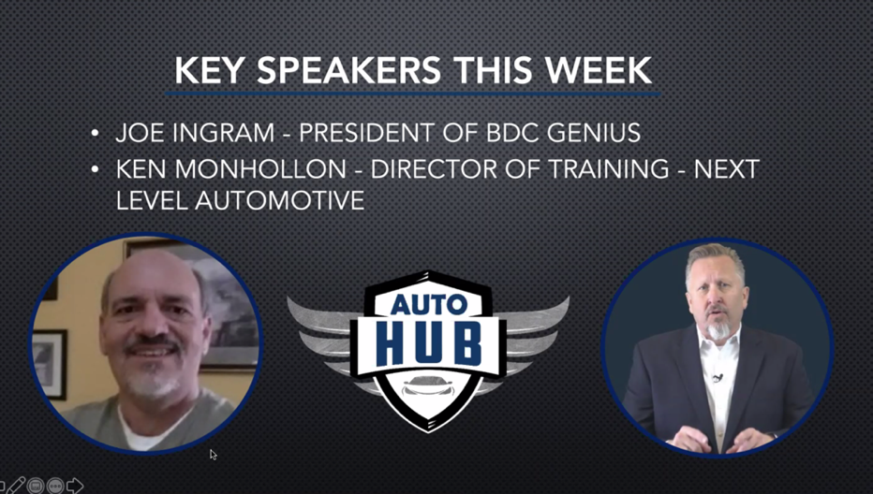

This Weeks Friday session

Calvin Bennett at Kar Global

Ric: You can download meeting minutes and best practices and good ideas https://www.autohubclub.com/

Brandon: Just bear with us as we get our website up for the group. Slack has not really taken off so please follow up on Instagram and Facebook.

What has changed: we are far from tracking phone ups and walk in, we are tracking leads right now.

Ric: What changes have you seen these days

Joe: What is being done daily, vs what is done at the end of a month. Management involvement in the CRM is up as well. How involved is the sales manager in the leads and deals? Following a process, is every lead getting the right process.

Ric: I was a manager for many, many, years, who is using the CRM accurately. Is anyone got their sales managers involved in the CRM.

Barry: What is outgoing vs incoming. What are the salespeople doing to drive traffic “Outbound activity” vs inbound activity?

Ken: We can’t paint everything with one brush in the service drive in terms of ELR for example. Look into the numbers and see what the opportunity really is with each customer vs ELR with the older employee for example. The numbers can be manipulated if we are not careful, for example.

Ric: What would you tell a dealer in terms of what numbers to measure?

Ken: Call me, I can help. I have seen a lot of changes and differences over the years. I taught a class for the OEM recently and staff in the room could get the numbers from the DMS but were unable to calculate the numbers manually.
Ric: There are a lot of us who are running dealerships who don’t understand effective labor rate etc.

Joe: Response time, show to sold, leads to appointment. Show to sold. New metrics lead to contact (how good are they and how good are the leads). How many touches per lead are happening “contact types” for example? Are the daily activities being done, what is their process?

Ric: Do you still talk about overall opportunities for the dealership.

Joe: What is your marketing and conversion rate at your dealership. Does your chat work, are you counting them for example? Most people will go to chat during operational hours. A chat lead to the prospect, you have already made contact. To me my chat leads are the hottest ones off my website. Give it to a manager not an internet salesperson. This is even true on the Service side.

Ric: How do we transition a chat into a service department?

Ken: It takes a lot of communication with sales, manager or BDC to make this happen. What we need to do is manage the service department like the sales department. We have lead opportunities, but we are not managing them correctly in the service department. 15 to 16 advisors 10,000 to 12,000 calls per month. Takes a tenacious management philosophy to get it done.

Logan: You can use trade in valuations to drive service opportunities based on the vin scanners. Anyone can scan a vin number and use the trade in value tool to identify opportunities. Your staff can use this tool as a sales or service tools.

Joe: I run opportunity reports in service every night to hand to salespeople for example. Lots of opportunities. These should be a part of your daily opportunities and process.

Brandon: What is a good example?

Joe: It takes service volume to make this work, dedicated process and staff. Norm Reeves Honda is a great example (they sell 100 cars per month). You must reward your service department to make this work. Same labor rate for these customers for example. You can do an appraisal on every car before it comes in, it is already waiting for them. Not a huge take rate, but there is an offer on every car.

Ken: I have seen this break down in the service department where you are taking money away from the service department and management by doing this. We need to work together.
Ric: Our biggest downfall is infighting between the teams. The process does not work if there is conflict.

Ken: You need a dedicated staff to work this process every day.

Dean: The four disciplines of execution. Lead indicators and lag indicators. How much gross is a lag indicator? Lead indicators are what we should be measuring. Identify the lead indicators (what is the goal) what to me measure. Are you consistently putting it in front of the people? What is the measurement.

You tube: here you go https://www.youtube.com/watch?v=aEJDliThj7g

Brandon: Would it be a good idea for an advisor to take photos of the vehicle? (V-Auto)

Ken: I would be cautious about how much of this could be done by a writer.

Joe: I would recommend a greeter or salesperson to do this.

Asif: I would recommend having a sales manager or salesperson do this.

Ken: A whiteboard out in the drive works.

An example from a dealer group in Vancouver
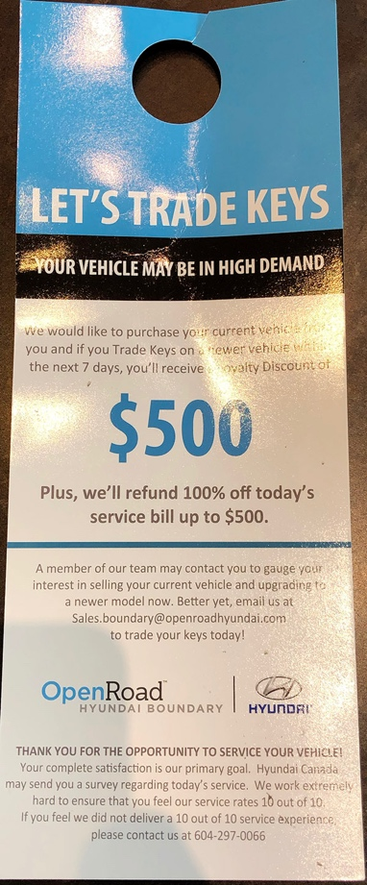
Wilson Mah: Look for any opportunity in terms of sales, F&I etc.

Joe: Service is the most process driven department. Must come from the top down. Process and accountability are key. 1,000 cars a month is not by accident. How do I make it more like a drive through (1 hour or less)? Service creates money, because of process. Sales needs to be mandatory and fun.

Brandon: You hold people accountable to your process and things get done.

Joe: The process was mandatory and needed to get done every time. You need to make the process mandatory. I am playing a numbers game the right way; I want people who do everything.

Ric: I have 140 stores that I work with directly. Send me a copy of your phone follow up plan. They don’t have it in writing. (email process, phone up process). Get it in writing.

Ken: Specifically, to technicians. Hours produced daily, communicate it daily. Have the conversation daily, make sure you hold people accountable to hours and proactivity and efficiently. Is he working effectively and maximizing the productivity of his time?

ASR – Additional Sales request “what are they doing with those opportunities”

Why is it important “is my tech doing what he needs to do to help the dealership”?

Ric: Two questions
One: Should you be tracking the ASR?
Two: Are you tracking the ASR?

Ken: If you are doing that are you communicating the results?

Ken: I like gross per repair order as a measurement (it takes away manipulation) parts and labor. Easy to calculate and will give you an eye-opening idea of what is going on. Appt set, show percentage, who is setting appointments, communicating the results. How many appointments does the advisor need to set every day?

Ken: Talk to the people in your service department and thank them. How many appointments do you have in the morning for Service for example?

Ric: One of the most common questions is what does good look like?

Joe: Here are the numbers: www.ingraminteractive.com/autohub

