Auto Hub Week 9 – The Retailers- “Digital Retail” June 8th, 2020

Ric Gregson-Moderator https://www.linkedin.com/in/ric-gregson-37011723/
gregsonric@yahoo.com
Ian Nethercott-Moderator https://www.linkedin.com/in/iannethercott/
ian@nabthat.com
Tiago Nunes-Notes https://www.linkedin.com/in/tiagonunessilva/
tnunes@wagonmaster.net

This Weeks Topic “Used Car Domination”

Ron Leggero Jr. - Dir, consulting sales, CDK Global
LinkedIn: https://www.linkedin.com/in/ronnieleggero/
https://www.cdkglobal.com/us

Brian R. Murphy - VP, Canadian Black Book
LinkedIn: https://www.linkedin.com/in/brian-r-murphy-72593217/ https://www.canadianblackbook.com/

Call count 30 plus

Ric: Mr. Brandon is moving on from Auto Hub Co-Host. He has a beautiful brand-new facility at Medice Hat to manage and focus his efforts. I would do the same.

Ric: Ian has a wealth of knowledge to be joining our team. As Co-Host Ian will be bringing to the table enthusiasm and outside the box ideas.

Vendor’s speak Friday sessions “More Details Soon”

Ian: Passion for all things automotive from young age. My vision for Auto Hub is to build the community from inside out. Platform to add value and having fun while growing the Auto Nation.

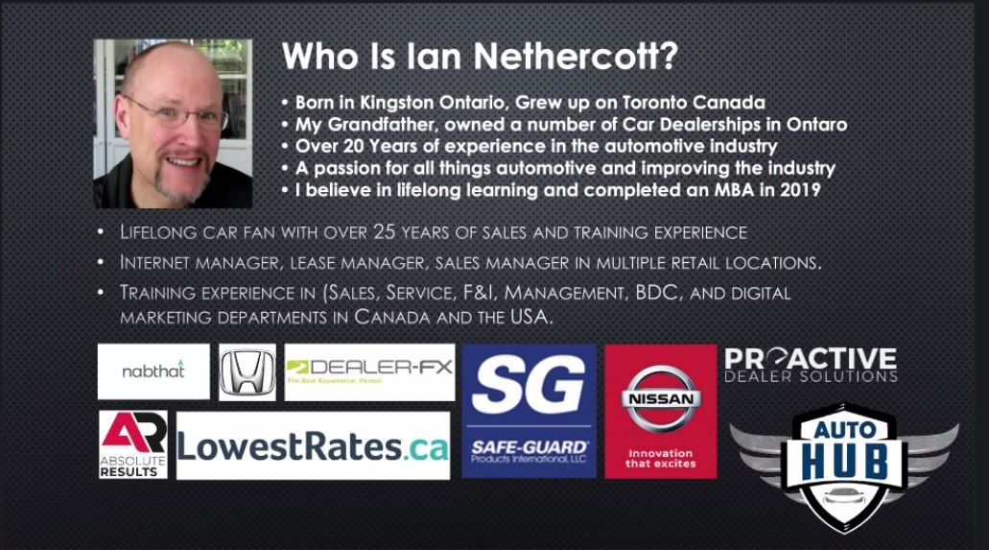

Ric: House keeping items standard as usual. Ask question, chime in, no selling of your products

Ric: Introduced Ron Leggero Jr. - Dir, consulting sales, CDK Global and Ron Leggero Jr. - Dir, consulting sales, CDK Global check their LinkedIn for complete profile.

Ron: Handles USA and Canada consulting for CDK. Learned a lot about Used Car. Take a step back before you talk about strategy.

Ron: In the beginning, lets streamline online digital processes. Processes vs Behavior are particularly important. Process that look at your inventory, remember the melting ice cubes analogy.
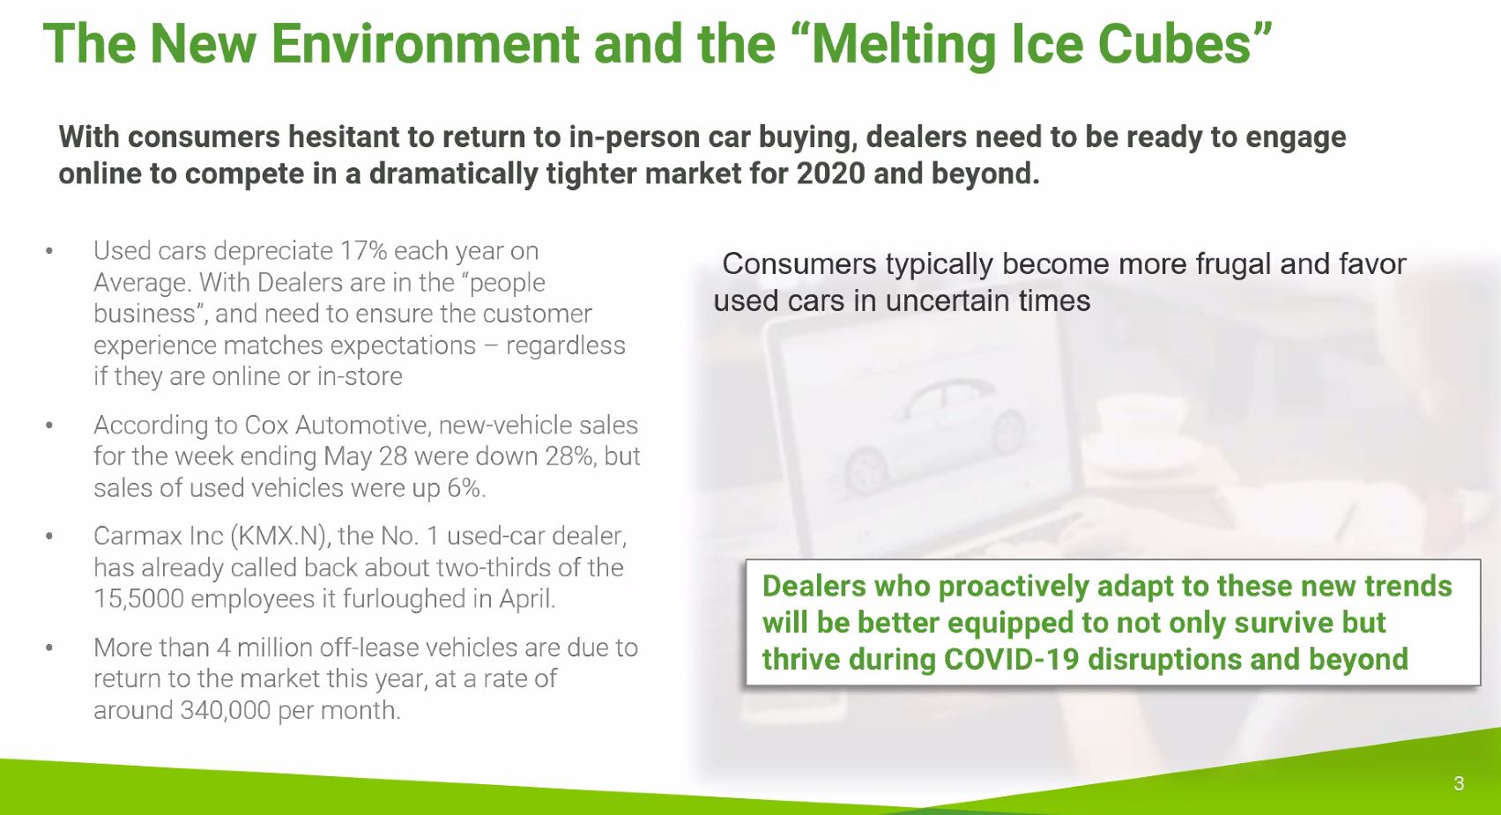

Ron: 30.000 – 40.000 lease cars are coming back in Canada/USA per month.

Ron: Don`t make bad decisions on trade in. Make an exit plan for every car you take in. Car appraisals are critical to success. The silo of bad communication is preventable.

Ron: Used car department can work hand in hand with the service department. Top 20% of dealers are able to recondition and have their cars customer-ready in approximately five days.

Ron: Ask questions to the people that work on the process. You will find things that you don`t know.

Ric: What is the difference between process and recommented behaivior?

Ron: SMART question to answer the behaivior. How many calls to hit our numbers? Are we doing this right? Is it happening daily/weekly/monhtly?

Ric: Every vehiche has to have an exit strategy, would you sign for 15-17% loan? Every vehichle has a different shelf life. Aging paramethers are different by OEM. Core inventory strategy vs other brands.

Ric: If you have a Lexus on inventory on a Chevrolet delaership what would you do Kevin?

Jason: A car like Lexus needs to be priced to move in 30 days.

Ric: Have a core and non-core strategy for shelf life is very imporant.

Jason: It has to be different you are right on that point Ric.

Jason: Sometimes if the colour is different also afffects the aging deadline.

Brian: Business as usual but not. We are doing our forecast looking at how the market is behaving. May car sales was down -44%.

Brian: Consumer confidence is what we will struggle coming out of COVID-19.

Brian: Negative GDP growth in Q1-Q3, drop in consumer confidence most likely scenario. A jump on unenmployemtn should lead to 25% drop in new sales in 2020. New level of sales of 1.4 milion units.

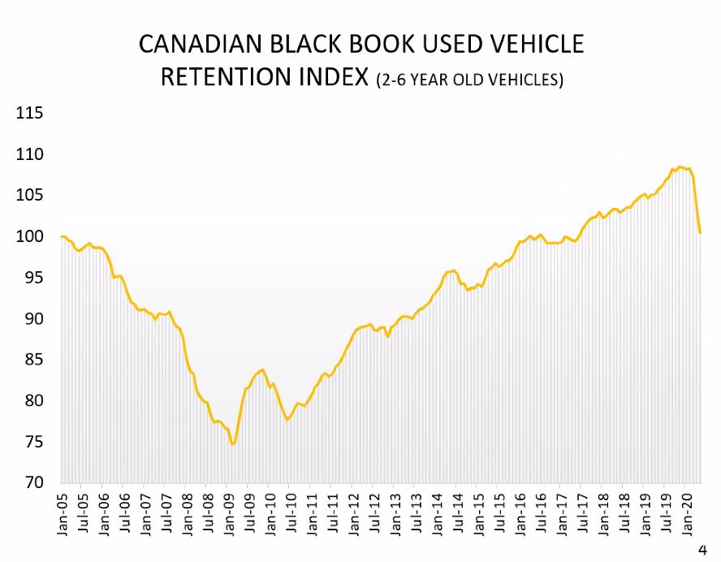
Brian: We think the botton of retail price should be down average 17%. Short term.

Brian: Lease rertun record levels expected for 2020 and 2021. Probanally in November bottom of pricing on retail.

Ian: What is your advise in the shoes of used car manager?

Brian: I wouldn`t have stuff on the lot that your are not 100% sure you will be selling. Expectations are slow declines every week.

Ian: Do you expect prices will be recovering on January 2021?

Brian: Slow receovery on January in 2021.

Ric: What is your take away on rental cars?

Brian: We expect that rental cars will start liquidade their inventory. Low millage could be a great opportunity. I have heard opportunity with no millage.

Brian: Could be a new source of opportuniy for dealers to buy from rentals car companies.

Ian: Thank you very much for your time!

Tiago: Would you expect that pricing to get back to normal to be 36 months?

Brian: That is correct that is the current trend of recovery.

Ric: What would you do if you were a dealer today?

Brian: I would be focusing on turning what I got as fast as possible as far as inventory. Your cost of goods are doing down so that is critical point to focus.

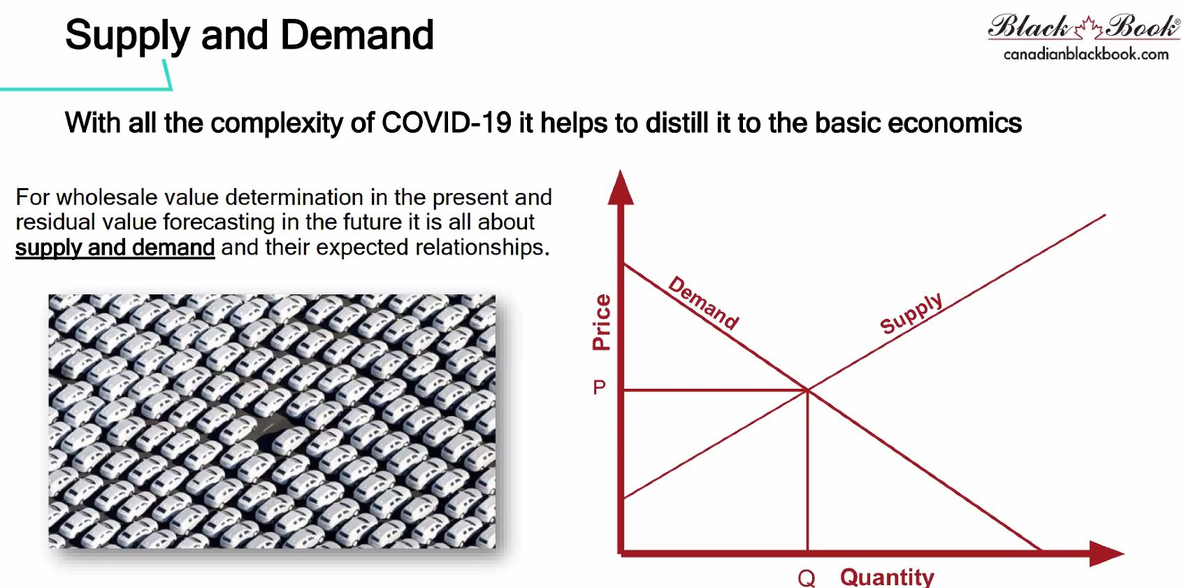
Brian: Lot rots over 90 days can be worth 6-7 point less. Don`t do that.

Ric: Would you cary 50 cars a your dealer lot?

Brian: We do expect that will be some shortage of new cars. I would not change the number, I would focus on inventory velocity as mentioned.

Ric: I would watch my margins. Have accountability to manage the positive demands that are available.

Ric: Thanks everyone!

Tiago: Thanks evveryone!

Auto Hub: Thanks everyone!

Ian: Ends meeting with a smile .

